Permissions for Sheet Integration

Step1: API’s

Enable :-

Google sheets api

Google Drive API

Step2: Service account and keys

Go to the API & Services and then create an new service account

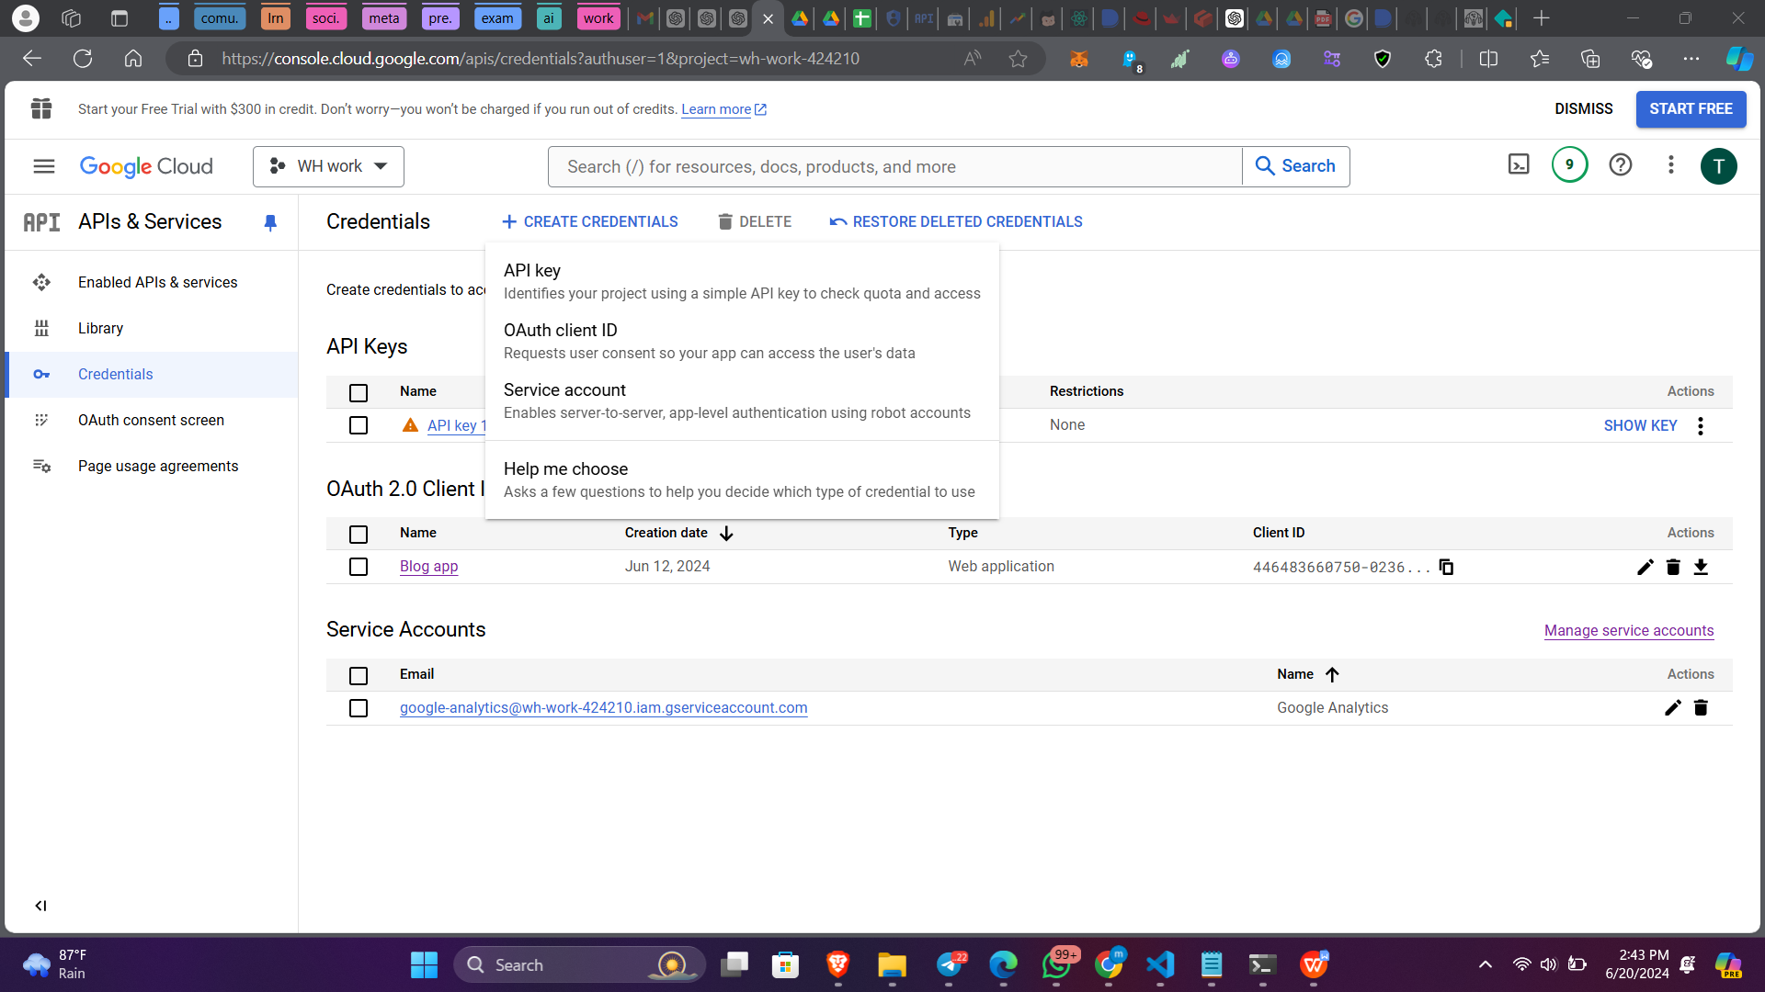

Now download the json file of the keys. The format of the keys would look like this  
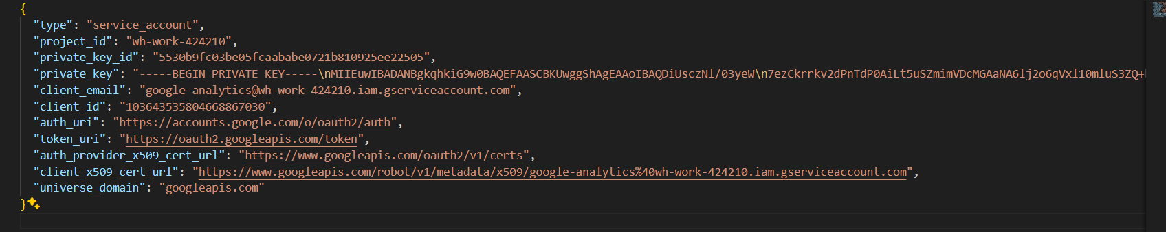

Step3 : Create a file named message in google sheets, This is where you can send messages.

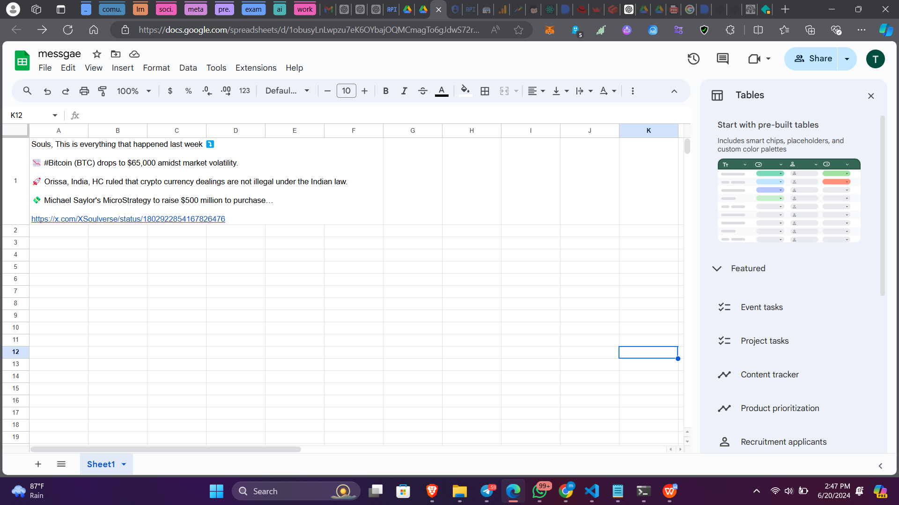

Also please add the email of service account in share option

